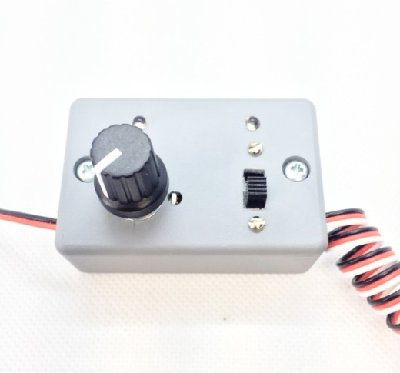
Turbine Tester
The Turbine Tester is designed to facilitate the testing and running of a model turbine that is mounted on a test bench or other surface, without the need for a working transmitter and receiver. It provides the signals required by the ESC to initiate the turbine’s start-up sequence, to allow it to be run at any speed from idle to full power, and to be shut down completely, all from the controls on the unit. It can be powered by the ESC’s on-board BEC (if present), or by a separate BEC or battery pack. Operation is simple and automatic, and requires no programming or other adjustments. The main control knob and switch simulate the actions of the throttle stick and throttle trim switch on the transmitter, and make the process of starting and running your turbine much easier.
Connect the ESC to the battery that powers the turbine as normal, and connect the servo cable coming from the ESC that would normally go into the receiver’s throttle channel to the cable coming from the Turbine Tester marked “ESC In”. If the ESC has an on-board BEC, this will be the only connection necessary. If the ESC does not include an on-board BEC, you will need to provide POWER from either a separate BEC, a 4-5 cell Ni-Cad/Ni-MH battery pack, or a 2S or larger Li-Po or LiFe battery. Connect the external battery pack to the cable coming from the left-hand side of the Turbine Tester marked “Battery In”.
When the unit is correctly connected to a suitable power source, the red LED above the Main Control Knob will be “On”. To start your turbine, begin with the Main Control Knob fully counter-clockwise (CCW), and make sure the Trim Switch is in the “Off” (down) position. (The green LED above the Trim Switch should be “Off”). Move the Trim Switch to the “On” (up) position, and the turbine should begin to spool up. (The green LED above the Trim Switch will be “On”). Once the turbine has started and is idling, turn the Main Control Knob clockwise (CW) to increase speed, CCW to decrease speed. To shut the engine down, turn the Main Control Knob fully CCW, and move the Trim Switch back to the “Off” (down) position. The engine should begin to spool down and shut off.
Note: The Trim Switch must remain in the “On” (up) position when controlling the engine’s speed with the Main Control Knob.

If you have any questions or problems, don’t hesitate to contact me. ENJOY!
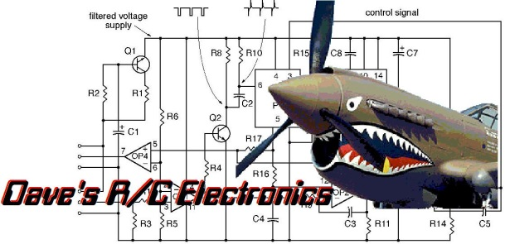
www.davesrce.com
sales@davesrce.com
(423) 544-1657
SCAN HERE

