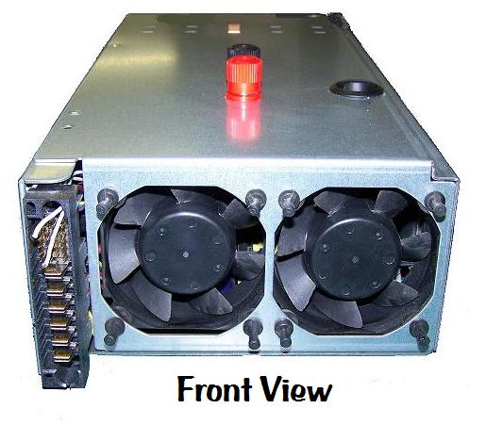
75 amp 12 volt Power Supply

This power supply consists of a computer server power supply that has been converted for use as a bench top power supply. It provides a highly regulated, high-current 12 volt output that’s perfect for use with battery chargers that require a lot of amps when charging at high current levels, or for use when charging several batteries at once. As with most computer-based power supplies, the circuit itself is overload protected, temperature protected, and short-circuit protected, making it almost impossible to damage in normal use, and is cooled by high-speed fans that protect the internal components even when operating at high current levels. If the outputs are shorted or overloaded, or if the unit overheats, it will shut down before damage can occur, and can be re-set by simply turning it off for a few seconds before turning it back on again.

The blade-type connectors on the front of the unit are normally used to connect it to the server tower, but 10 gauge wires have been added inside to bring the unit’s output up to the banana jacks on top. Should you ever need to connect to the unit’s outputs separately, the diagram below shows the polarity of the 6 blade connectors on the front panel, Because this power supply is capable of producing over 75 amps of 12 volt DC current, extreme caution should be exercised when making any other connections to the unit.

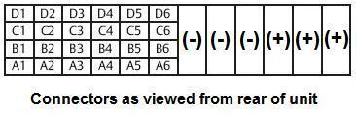

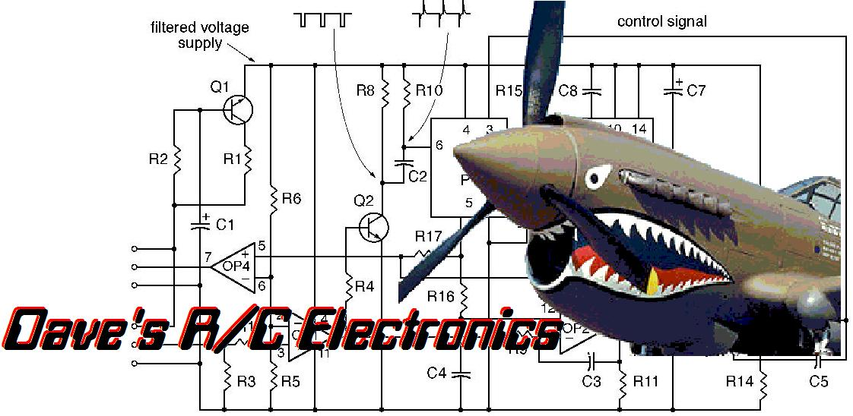
If you have any questions or problems, don’t hesitate to contact me. ENJOY!

www.davesrce.com
sales@davesrce.com
(423) 544-1657
SCAN HERE

