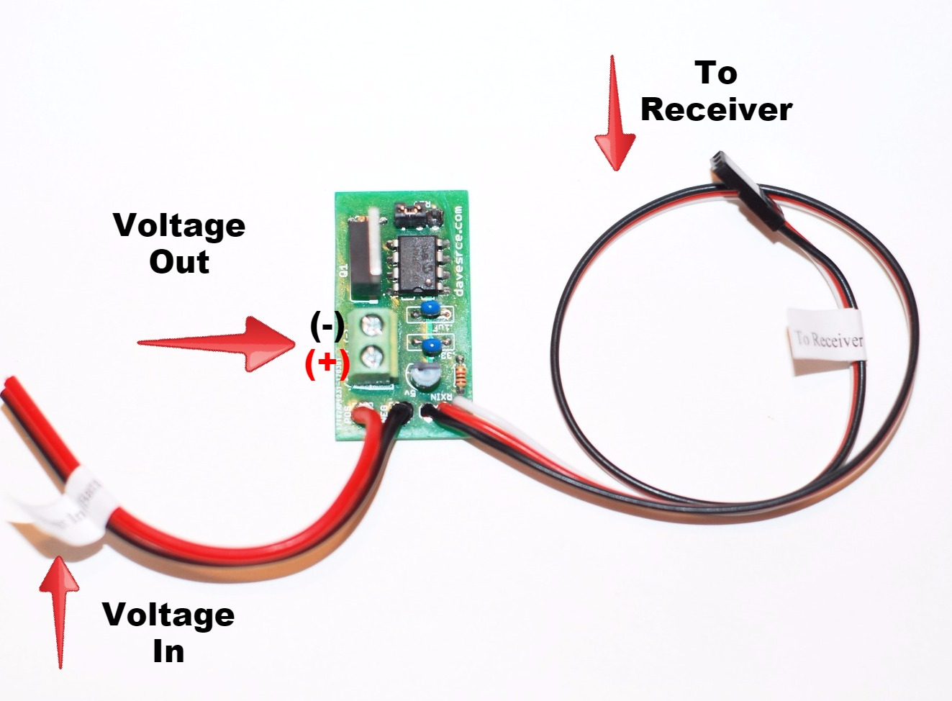

Multi-Purpose R/C Switch

The Multi-Purpose R/C Switch is designed to allow you to control a variety of devices, like LED light strips, smoke pumps, and even glow plug drivers, all from your transmitter. If plugged into a spare channel, it can be controlled with that channel’s switch or knob, or it can be connected using a servo wye to a channel controlled by a stick, like the throttle channel. Operation is very simple, and it can be used to control almost any device that is designed to be powered by a battery. The output of the switch is rated at over 40 amps, so it’s safe to use even with high-current loads like multiple LED light strips or glow plugs that require several amps of current.
To use the switch, first decide which channel you want to use to control your device, and plug the male servo plug into that channel on your receiver. Connect the black and red wires coming from the circuit board to the device’s battery or voltage source, making sure to observe the correct polarity, black for negative (or ground) and red for positive. Now connect the power wires from the device you want to switch to the green terminal block on the right side of the board, again observing the correct polarity. Note that the bottom terminal in the picture above is the (+) connection, the one nearest to the red battery wire, and the top terminal is the (-) connection.
Your Switch is now ready to use. To turn your device on, simply flip the switch or rotate the knob on your transmitter that corresponds to the channel on your receiver into which the Multi-Purpose R/C Switch is plugged, and the device will come on. If you find that the action of the switch or knob is opposite from what you desire, you can easily reverse the operation of the circuit. Locate the 3-pin Reversing Jumper in the picture above. Note that the jumper covers only 2 of the 3 pins at any time, the center pin and the pin on one side. To reverse the action of your Switch, just move the jumper to cover the center pin and the pin on the opposite side, and the action of the circuit will be reversed.

If you have any questions or problems, don’t hesitate to contact me. ENJOY!
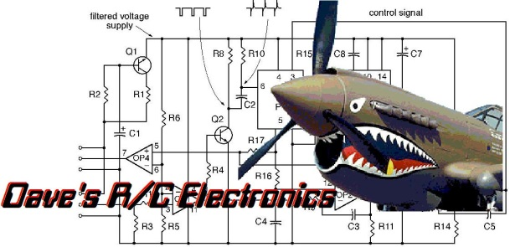
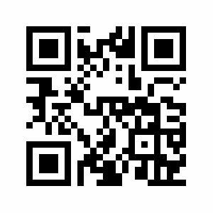
www.davesrce.com
sales@davesrce.com
(423) 544-1657
SCAN HERE

