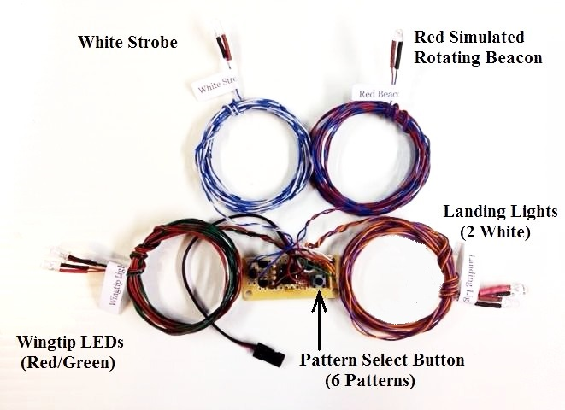
All-in-One Navigation Light Set

The All-in-One Navigation Light Set is designed to plug into any spare channel on your receiver, and provides Navigation Lights, an Anti-Collision Strobe, a Simulated Rotating Beacon, and Landing Lights, most of which are switchable from the transmitter. It also features 6 different strobe/beacon patterns that can be selected by the small push-button switch located on the main circuit board. The 6 patterns change the speed of the rotating beacon and the number of times the strobe blinks between pauses. The last pattern chosen is stored to the circuit’s memory so that it retains the setting even after the plane’s battery is removed.
In order to allow the various outputs to be switched from the transmitter, the circuit should be plugged into a proportional channel, typically channel 6 or higher. Avoid using the gear channel unless you are certain that your radio allows proportional control of the gear channel. Adjust the ATV or End Point of the channel you choose to 90-95% in each direction, but no more than 95%. The channel you select should be one that can be controlled with a knob or slider, and/or a 3-position switch. The All-in-One Navigation Light Set has 4 modes, which respond to approximately the programmable channel mixes shown below:

Mode #1: Wingtip (Navigation) Lights On-----as soon as the receiver is turned On----0%
Mode #2: All of the above, plus Simulated Rotating Beacon On---------- greater than 25%
Mode #3: All of the above, plus Anti-Collision Strobe On-------------------- greater than 50%
Mode #4: All of the above, plus Landing Lights On--------------------------- greater than 75%

Plug the circuit into the receiver, and rotate the knob fully Counter-clockwise (CCW). The Wingtip lights (red/green) should be On, all others should be Off. If they are not, reverse the channel in the transmitter’s programming. As you rotate the knob that controls the channel you selected, you should see the lights come on in the order of the 4 modes above. If you wish, you can use a 3-position switch and programmable mixes to control modes 2,3, and 4. The 6 available patterns can be selected via the small pushbutton switch on the main circuit board. The 6 patterns are listed below:
#1: Single-blink Strobe/normal Beacon speed #4: Single-blink Strobe/slow Beacon speed
#2: Double-blink Strobe/normal Beacon speed #5: Double-blink Strobe/slow Beacon speed
#3: Triple-blink Strobe/normal Beacon speed #6: Triple-blink Strobe/slow Beacon speed

(continued on back)

Once you’ve scrolled through all 6 patterns, the next button press will cause all the LEDs to fade up and down repeatedly, indicating you’ve gone through the available patterns and are about to re-start back at pattern #1. About 15 seconds after your last selection, the circuit will save the current pattern to its memory so it will start in that pattern every time, unless (or until) it is changed again.

If you have any questions or problems, don’t hesitate to contact me. ENJOY!
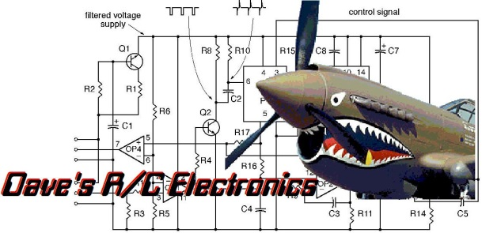
www.davesrce.com
sales@davesrce.com
(423) 544-1657
SCAN HERE

