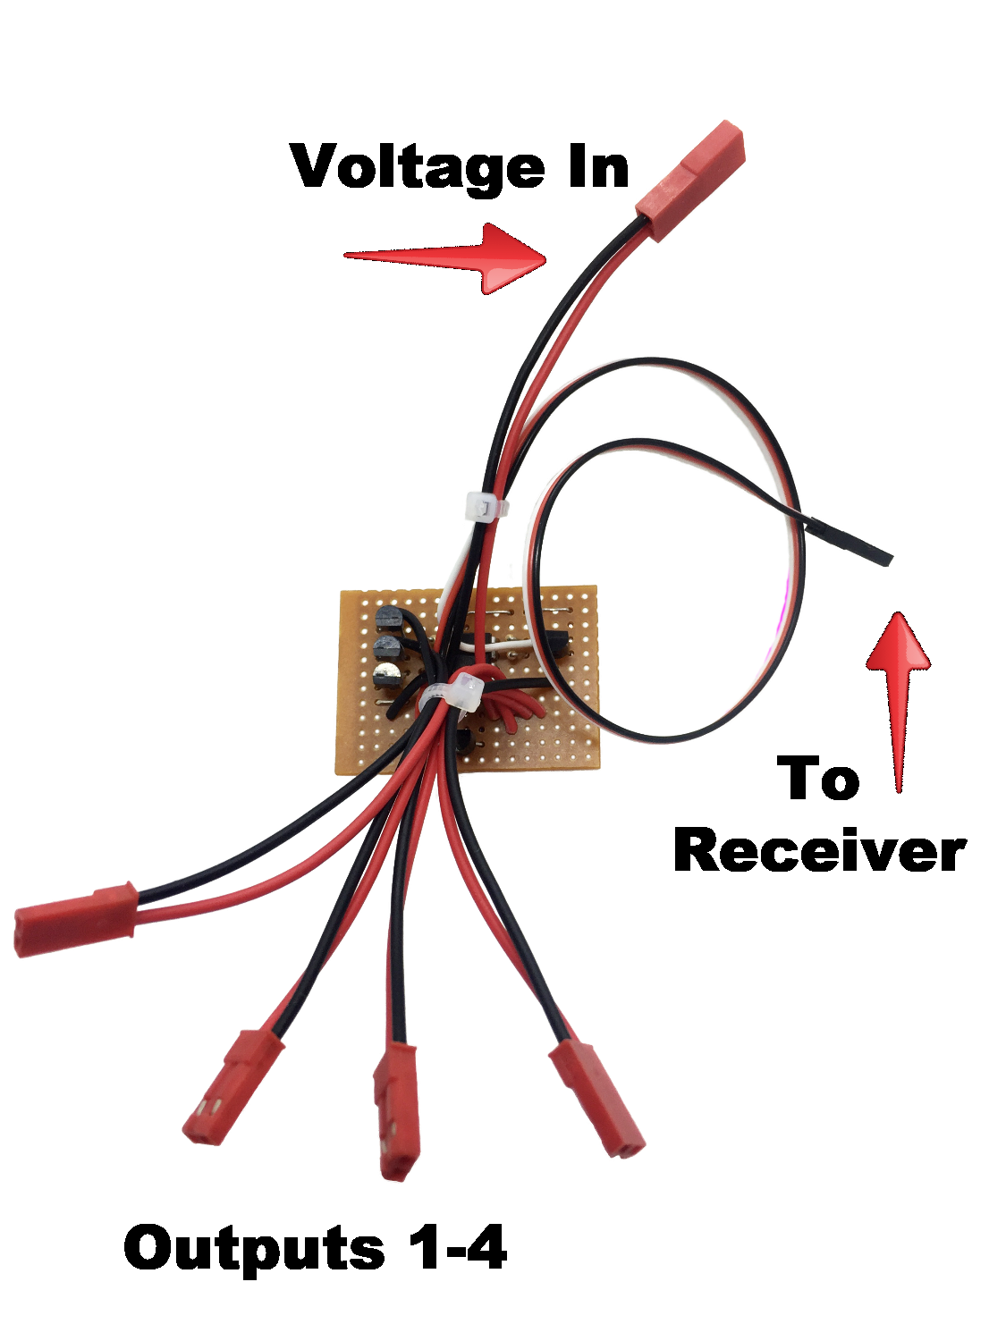
Multi-Output R/C Switch

The Multi-Output R/C Switch is designed to allow you to control up to 4 separate devices using a single, proportional channel in your receiver. As the channel is advanced, the outputs (numbered 1-4) each turn on in order, and once on they stay on as the channel is advanced. The circuit is regulated, which allows it to be used on any receiver, including high-voltage receivers. The devices being controlled can be powered by any external voltage source or battery, allowing the switch to control devices like LED light strips that require 12 volts or more. The outputs are buffered with a transistor that allows up to 800mA of current for each output. This switch differs from our Sequential R/C Switch in that multiple outputs are on at the same time, which is especially useful for controlling things like navigation lights where you may want to keep one set of lights (like wingtip lights ) ON, while controlling landing lights separately.
To use the switch, plug the male servo plug marked “To receiver” into an open, proportional channel on your receiver. Note: The channel used MUST be a proportional channel, typically channel 6 or higher. On many transmitters the gear channel (typically channel 5) is not proportional. If you want to use it in your model’s gear channel, check your transmitter’s manual to make sure it can be set up as a normal, proportional channel. The circuit features 5 modes as listed below:

ATV or (Channel Setting) | Function
0% or (-100) full CCW | All outputs Off
25% or (-50) | Output 1 ON
50% or (0) -center | Outputs 1 and 2 ON
75% or (+50) | Outputs 1, 2, and 3 ON
100% or (+100) full CW | All Outputs (4) ON

(continued on back)

Connect the male JST lead marked “Voltage In” to the battery or power source that will supply the devices you are switching, and connect the remaining female JST leads marked “Output #1, Output #2, etc.” to each device. Power your transmitter and receiver on, and as you advance the channel using the knob, stick, or slider for that channel, the devices connected to Outputs 1-4 will turn on/off as the channel is moved back and forth. You can go from any position to any other position as you wish, there is no need to return the channel to center or to the off position before selecting a new mode.

If you wish, you can program a series of mixes and assign a switch on your transmitter to control the channel being used, however, some allowances may have to be made because few transmitters offer a 4 or 5 position switch. The settings in the chart above will assist you in finding the correct settings for each mix to toggle the 4 outputs on/off. Experiment with your settings and you may find a compromise that works well for your application.

If you have any questions or problems, don’t hesitate to contact me. ENJOY!
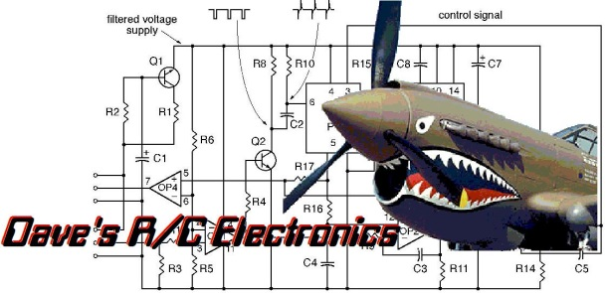
www.davesrce.com
sales@davesrce.com
(423) 544-1657
SCAN HERE

