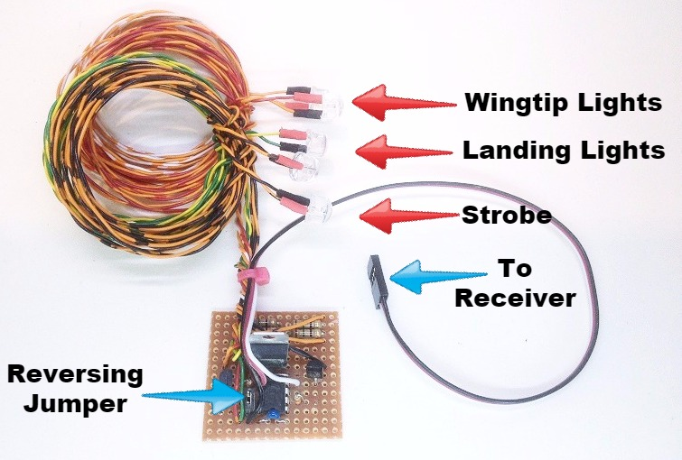
Basic NavLights – 8mm (Giant Scale)

The 8mm Basic Navlights set includes 2 wingtip lights (1 red, 1 green), 2 landing lights (white), and 1 strobe (white or red). The strobe can be set to 2 different blink patterns, a steady, single-blink or a quick double-blink. The LEDs used in this set are ½ watt 8mm High-Output LEDs that feature a special lens that makes them visible at a much greater angle (120 degrees) than a normal LED. The wingtip lights and strobe will come on as soon as the receiver is turned on, and the landing lights can be switched on/off from the transmitter. The circuit can be plugged into any channel on your receiver, either by itself or with a servo "wye". I suggest you use your receiver’s gear or flap channel, and if necessary, connect it using a wye cable to your retract or flap servos. You can even install a wye on the throttle servo and use the throttle stick to control the landing lights. Whatever channel you chose, note that if the landing lights come on at the wrong time, like when the flaps or gear are up instead of down, or when the throttle is high instead of low, their action may be reversed without changing your radio’s programming. Simply remove the black plastic jumper located just to the right of the black chip on the circuit board. Refer to the picture above for the reversing jumper’s exact location. If you prefer, you can also program a mix and/or assign a different switch on your transmitter to operate the landing lights. Once the receiver has been turned on, the wingtip lights and the strobe will come on immediately, but the landing lights must be “armed” before they can be switched on/off. To arm them, simply move the switch (knob, or stick) that controls them back and forth one complete cycle. They can now be switched on/off at any time.
The position of the switch (knob, or stick) that controls the landing lights when the receiver is first turned on (each time) is what determines the blink mode for the strobe. To toggle from one blink mode to the other, turn the receiver off, move the switch (knob, or stick) that controls the landing lights to the opposite position, and turn the receiver back on.

(continued on back)

The circuit utilizes a regulator that limits voltage to the chip and LEDs to 5 volts, so it can be safely used with any receiver, even HV (high voltage) receivers that are powered by 2S or 3S battery packs. The 8mm LEDs draw about 120mA each when illuminated -- the strobe draws much less because it is “blinking” -- but total circuit draw is still so low that a separate battery is usually not necessary. The set will operate just fine using the receiver’s battery pack, or in the case of electric models, the main flight battery.

If you have any questions or problems, don’t hesitate to contact me. ENJOY!
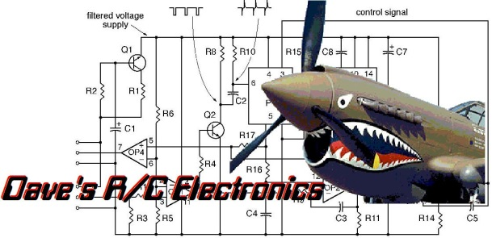
www.davesrce.com
sales@davesrce.com
(423) 544-1657
SCAN HERE

